Mock up OOAD - David Hurley, Dylan Cahalane

Front screen: <https://wireframe.cc/pro/edit/244637>

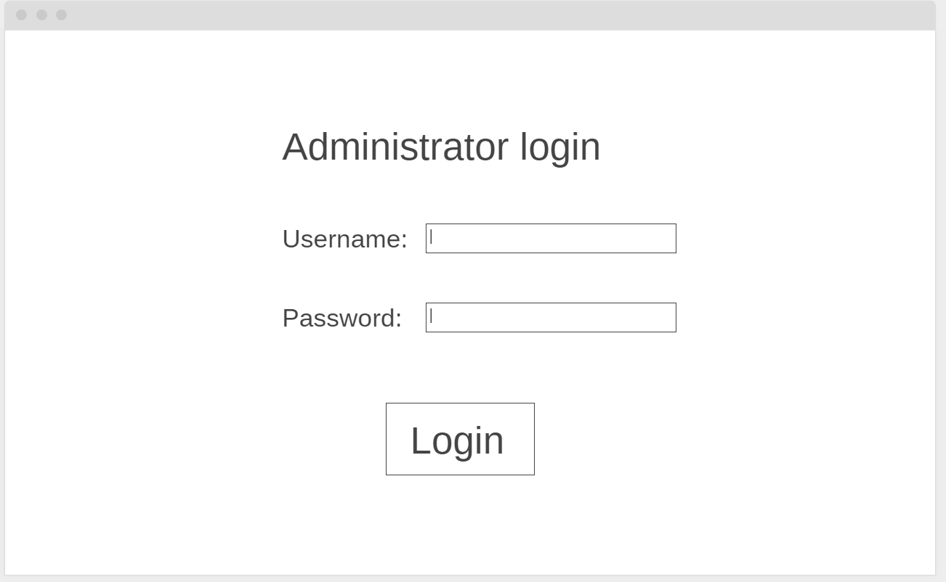

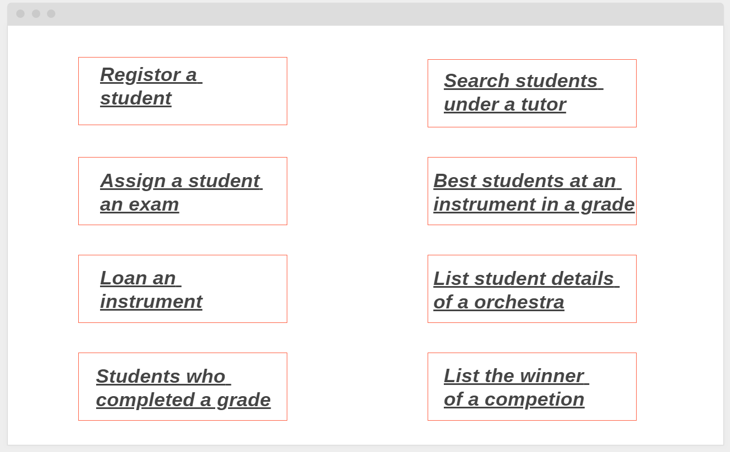

1. Register a student route. 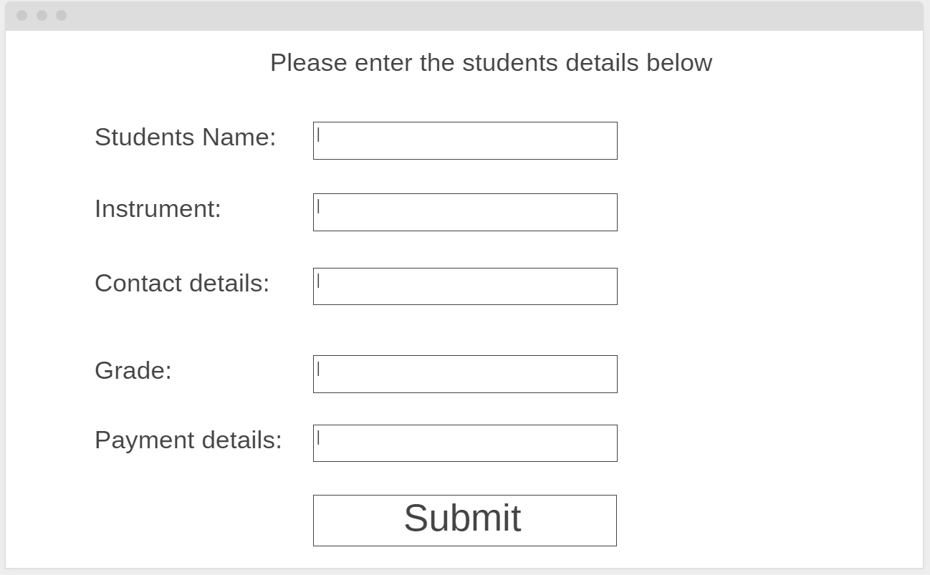
2. Registor a student to an exam:

Press “create exam”

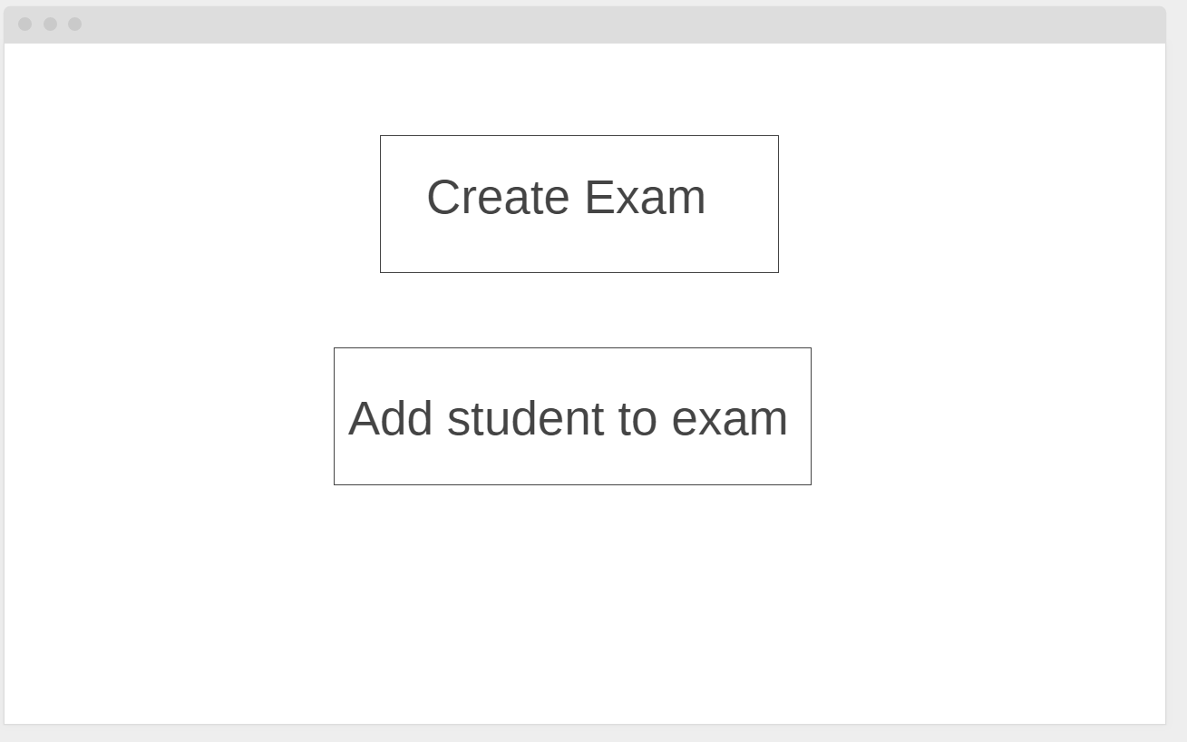

Create exam screen: enter exam details

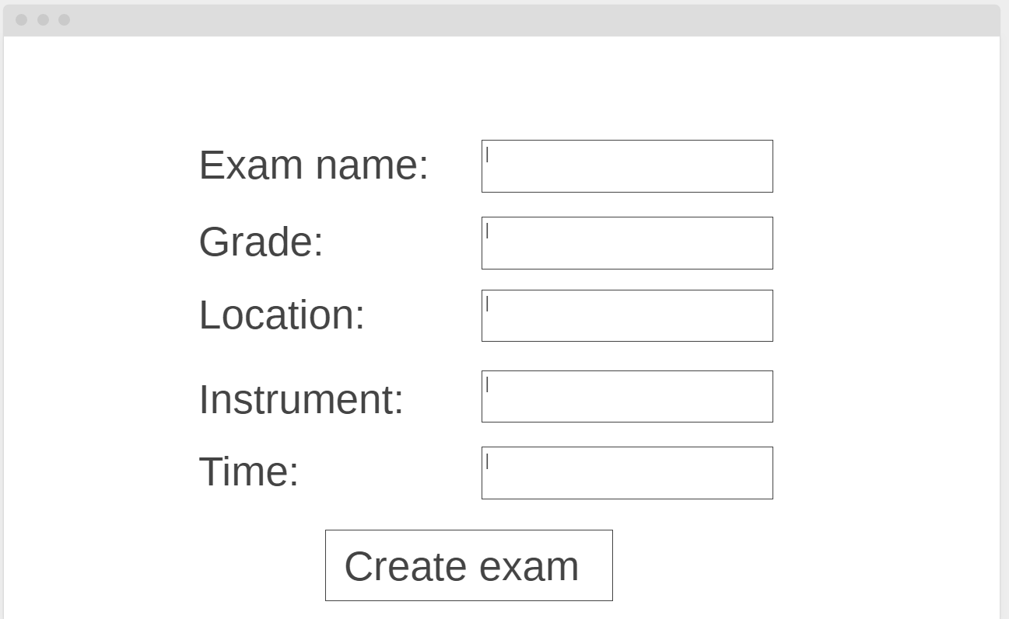

Add student to exam:

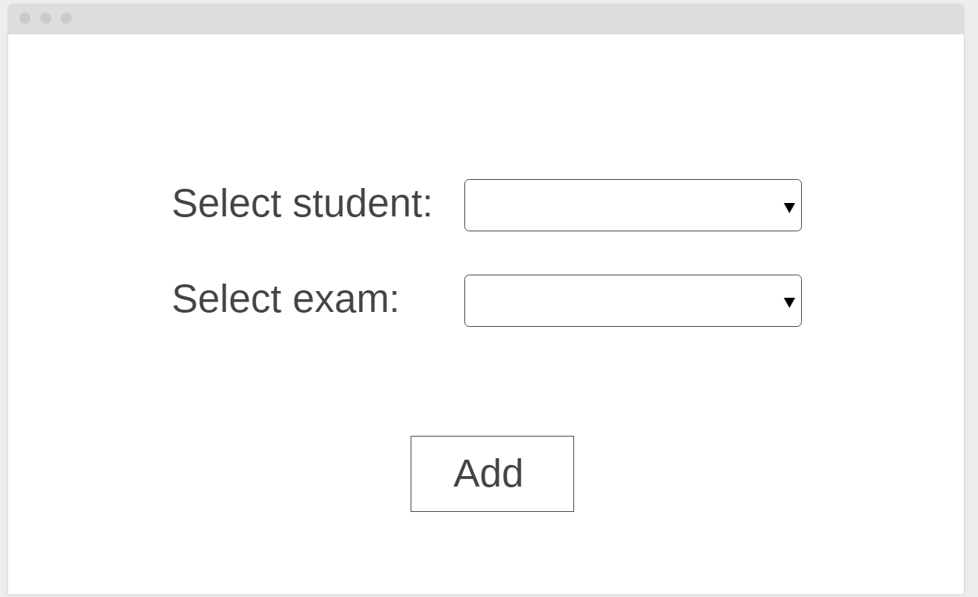

3.

Loan an instrument to a student screen

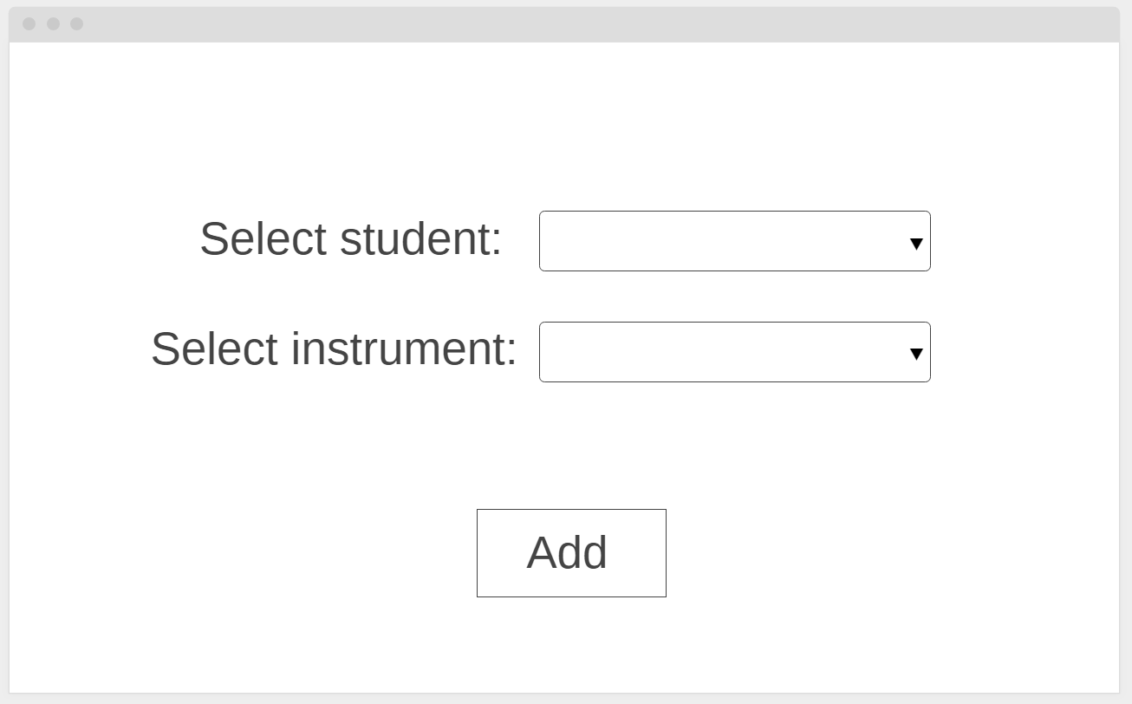

1. Find students who completed a grade in an instrument screen

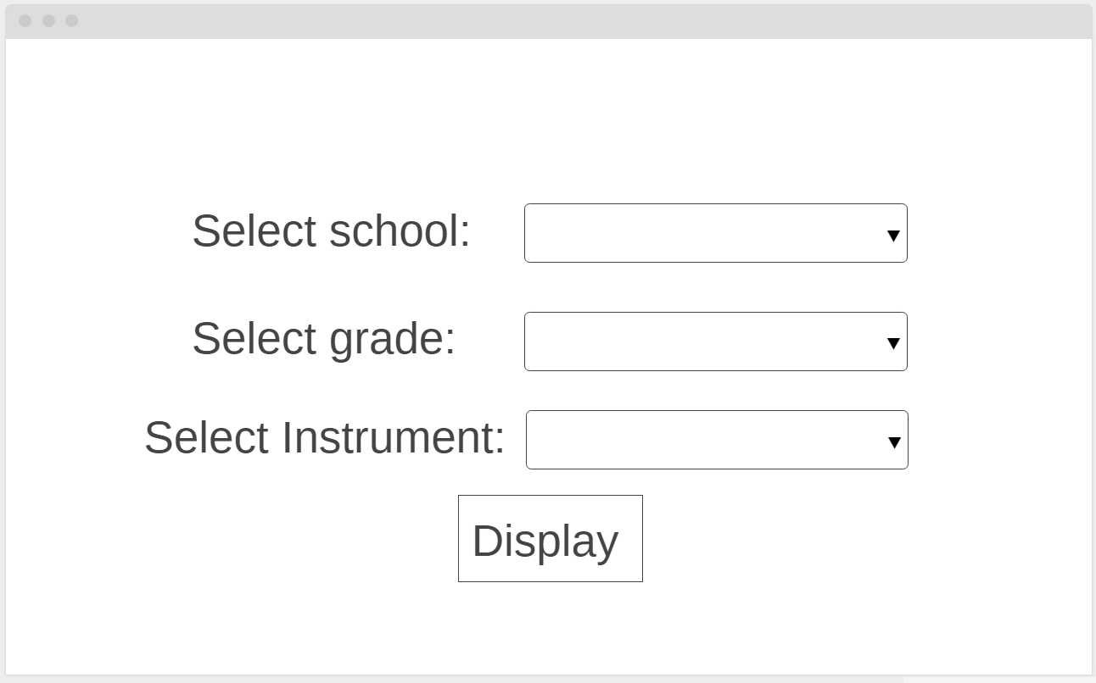

1. Students under a certain tutor screen

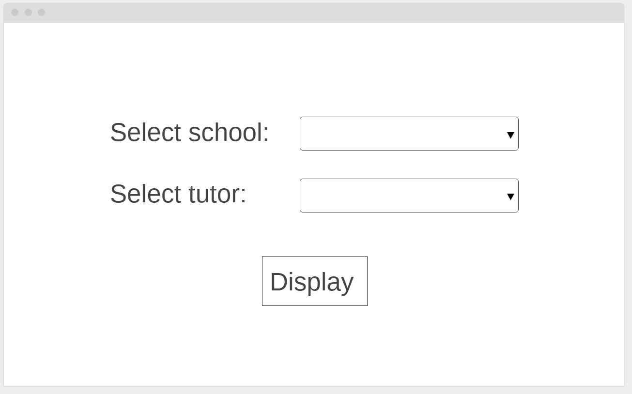

1. Best student screen

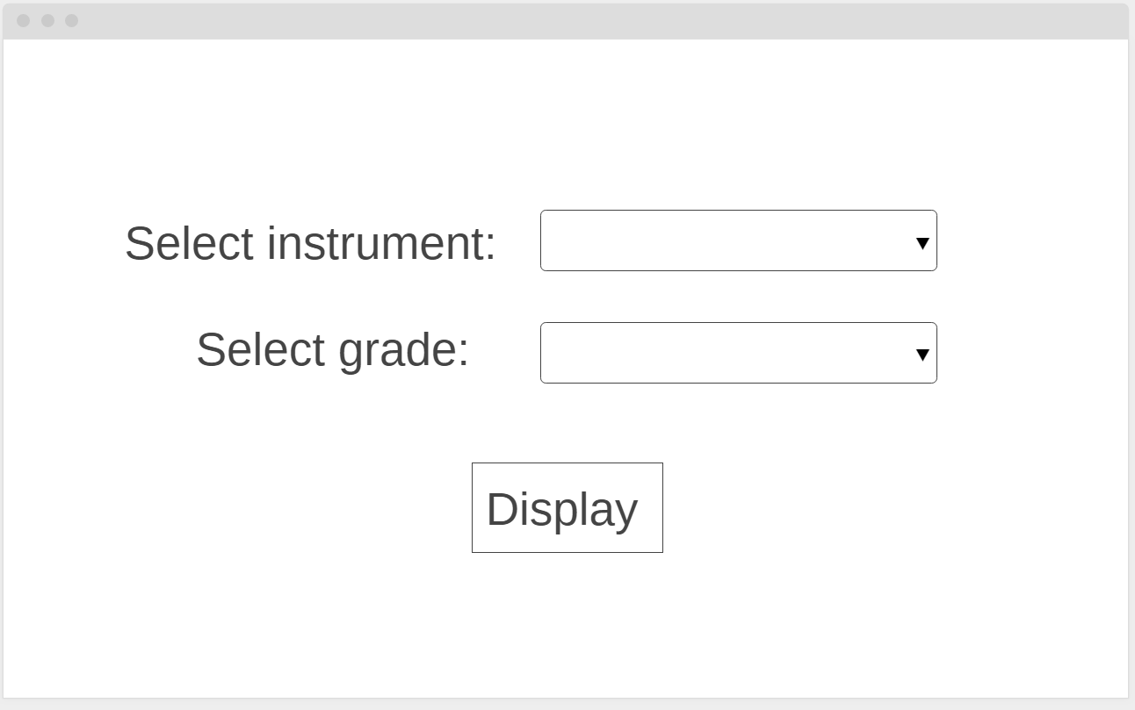

1. listing orchestra screen

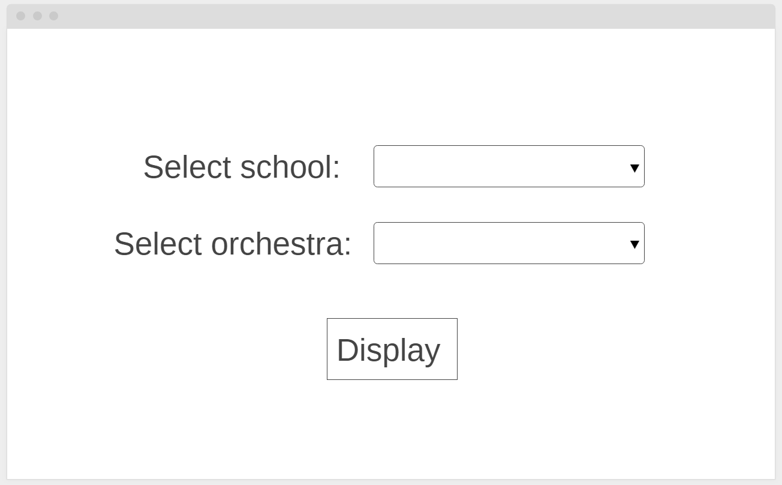

1. winners of competition screen

